RESOLUTION NO.__________

RE: CERTIFICATE OF APPROPRIATENESS UNDER THE
PROVISIONS OF THE ACT OF THE PENNSYLVANIA
LEGISLATURE 1961, JUNE 13, P.L. 282 (53
SECTION 8004) AND BETHLEHEM ORDINANCE NO.
3952 AS AMENDED.

WHEREAS, it is proposed to replace the neon signage with similar signage at 320 E. Third St.

NOW, THEREFORE, BE IT RESOLVED by the Council of the City of Bethlehem that a Certificate of Appropriateness is hereby granted for the work.

Sponsored by: (s)

(s)

ADOPTED BY COUNCIL THIS DAY OF

(s)
President of Council

ATTEST:

(s)
City Clerk

HISTORIC CONSERVATION COMMISSION

CASE # 357 – It is proposed to replace the neon signage with similar signage at 320 E. Third St. OWNER/APPLICANT: Ashley Development / Sunset Tan

The Commission upon motion by Mr. Evans and seconded by Mr. Lezoche adopted the proposal that City Council issue a Certificate of Appropriateness for the proposed work described herein:

- The proposal to replace the neon signage with similar signage at 320 E. Third St. was presented by Barbara Pate.

- The original aluminum sign faces will be removed and new aluminum sign faces installed with the same size and look of the originals.

- The reason for the changes to the sign is a new name for the business.

- The existing neon and back plates will be used.

- The overall size is 40” x 96”.

- All details of the sign will remain as in the past.

- The proposed work was approved by a unanimous vote.

CU: cu

By: 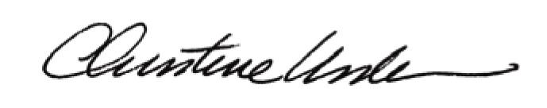

Date of Meeting: October 18, 2010 Title: Historic Officer

